Effects of Temperature and Working Day Status on Bike Rentals
Thasin Kamal
Spring 2026




Introduction
Motivation: I chose this topic because I believe efficient public transportation is crucial for society to function properly, and understanding factors that influence bike rental usage can help improve transportation planning and resource allocation. This project explores how the temperature and workdays impact bike rental behavior.

Research Questions:
Research Question 1 – What is the relationship between temperature and the number of bike rentals?
Research Question 2 – Do bike rentals differ between working days and non-working days?

Methods
Data Collection: My sample data came from the UCI Bike Sharing Dataset. It contains daily records of bike rentals. Each observation represents a single day. The final sample size that I used for my analysis is 731 days.

Measures:
- My response variable is cnt, which represents the total number of daily bike rentals. My numeric explanatory variable is temp. It represents the temperature and is measured on a 0-1 scale from low to high temperature. I am not using Fahrenheit or Celsius to measure this variable. My categorical explanatory variable is workingday (Yes for working day and No for non-working day).

Analysis Method: I used descriptive statistical methods, including summary statistics and graph displays. I also used a multiple linear regression model to look at the relationship that both of my explanatory variables (temperature and working day status) have with my response variable (daily bike rentals). I conducted all my analysis using R.
Descriptives
Table 1 – Descriptive Statistics
 | Center | Spread
Bike Rentals (cnt) | Mean = 4504 | Range = 22-8714
 | Center | Spread
Temperature (temp) | Mean = 0.495 | Range = 0.059-0.862
 | Yes Count | No Count
Working Day | 500 | 231
Results
Table 2 – Model Results
 | Estimate | St. Error | t-stat | p-value
Intercept | 1142.1 | 177.5 | 6.44 | < 0.001
Temperature | 6625.0 | 305.6 | 21.68 | <0.001
Working Day (Yes) | 117.4 | 120.3 | 0.98 | 0.329
Model df: 728
R^2: 0.395

Assumptions
- Random sample: The observations were collected from a random sample of days, as such, this assumption is met.
- Independent Observations: I am assuming that the independent observations assumption has been met as each observation represents a different day and the data does not show any indication of dependent sampling.
- Linearity: Residuals vs fitted plot shows a very slight downward curved pattern, and this indicates that the linearity assumption is not completely met, however, the deviation is not severe.
- Residuals have equal variance (homoskedasticity): The scale-location plot shows a very slight increase in the spread of the residuals as the fitted values are increasing. This indicates very low heteroskedasticity. As such, this assumption is not fully met.
- Residuals are normally distributed: The Q-Q residuals plot shows that the residuals are approximately normally distributed. There are only minor deviations from the reference line. I would say this assumption has been met.
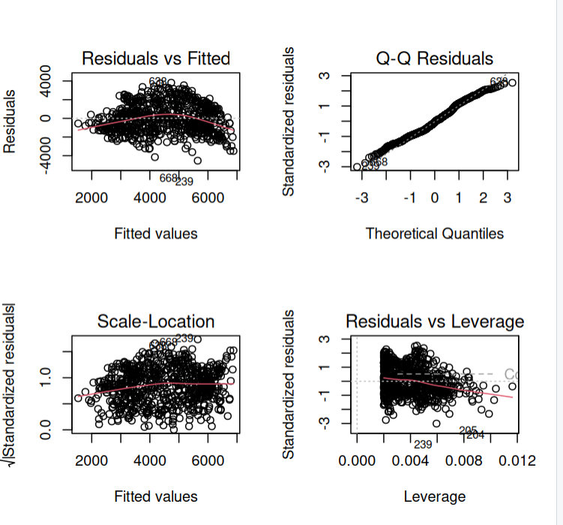
Multivariate Plot

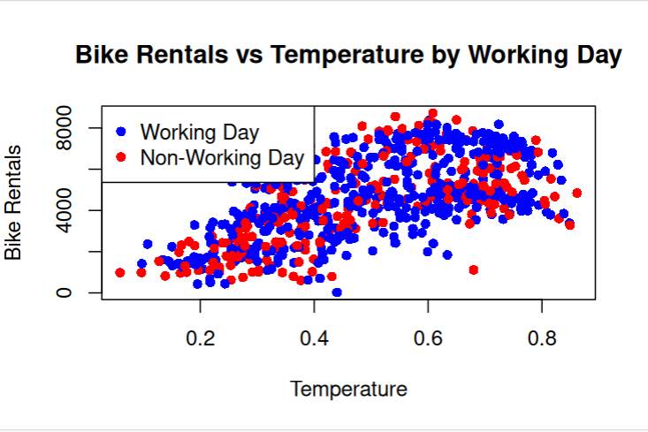

Discussion
Interpretation:
- Temperature is a significant predictor of daily bike rentals as the coefficient on temp is 6625.0 and the p-value (2e-16) is < 0.05, suggesting a statistically significant relationship.
- As temperature increases, the number of bike rentals increases, which means that warmer weather leads to higher bike rentals.
- Working day status is not a significant predictor of bike rentals when controlling for temperature as the coefficient on workingday is 17.4 (average number of bike rentals on working days is about 117 units higher than on non-working days) but the p-value is 0.329, which indicates that the relationship is not statistically significant.
- There is no strong difference in bike rentals between working and non-working days after accounting for temperature. The model explains about 39.5% of the variation in bike rentals as the R² is equal to 0.395. This tells me there’s a moderate fit.

Limitations: Not all relevant factors were included in the regression model, such as humidity and windspeed, and these variables could have also affected bike rental behavior. There were also slight violations of the constant variance and linearity assumptions, which might affect how accurate the model is. Also, because this is just an observational dataset, I would not rely on making casual inferences from it.

Implications: Temperature outside is a very important factor affecting bike rental usage, with higher temperatures leading to a greater demand for bike rentals.

Future Research: Research should try to expand and account for confounding factors, such as humidity and rainfall, or the day of the week to make the model more comprehensive and reliable. If I conducted this study again, I would include these relevant variables in my study to try to account for confounding variable bias as much as possible.

References:
Fanaee-T, H., & Gama, J. (2013). Bike sharing dataset [Data set]. UCI Machine Learning Repository. https://archive.ics.uci.edu/ml/datasets/bike+sharing+dataset

